**CS615 –Storyboard and Sketches**

**Group 4**

**Group members:**

**• Sammed Jain Dharmapal Prakash**

**• SriCharan Mohan Kumar**

**• Sukruth Kotturu**

**Group name: Pixels**

**Storyboards**

**Storyboard 1:**

**By Sammed Jain Dharmapal Prakash**

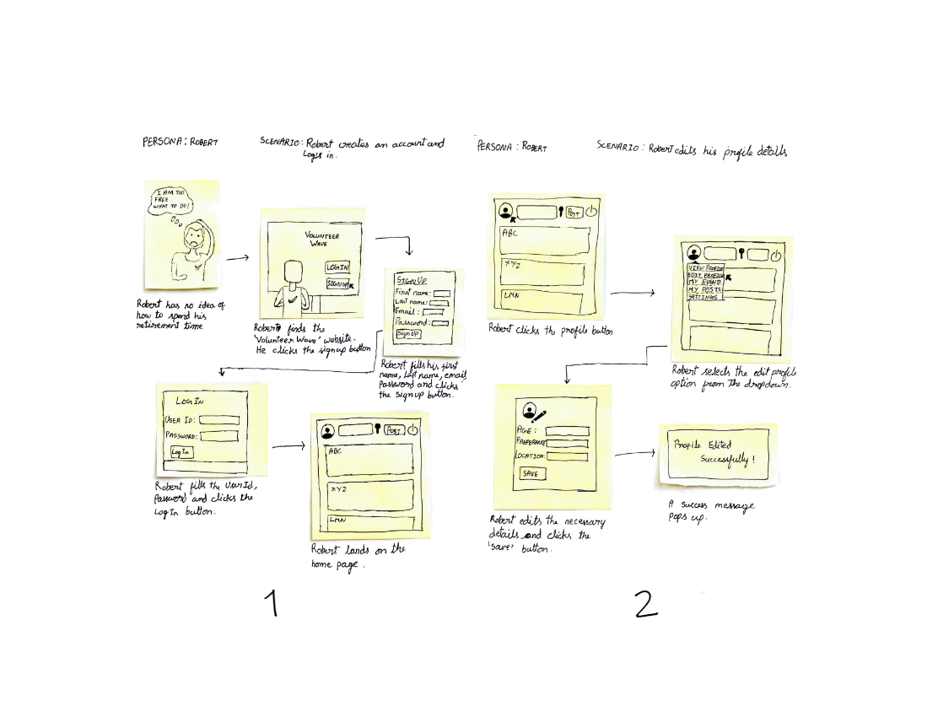

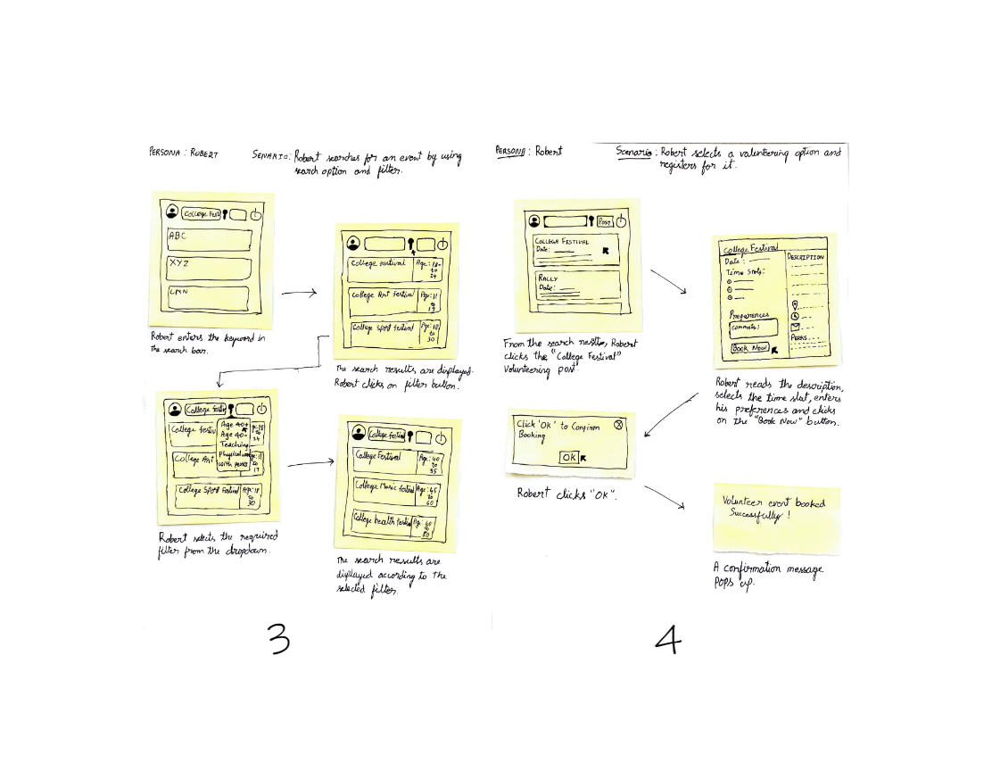

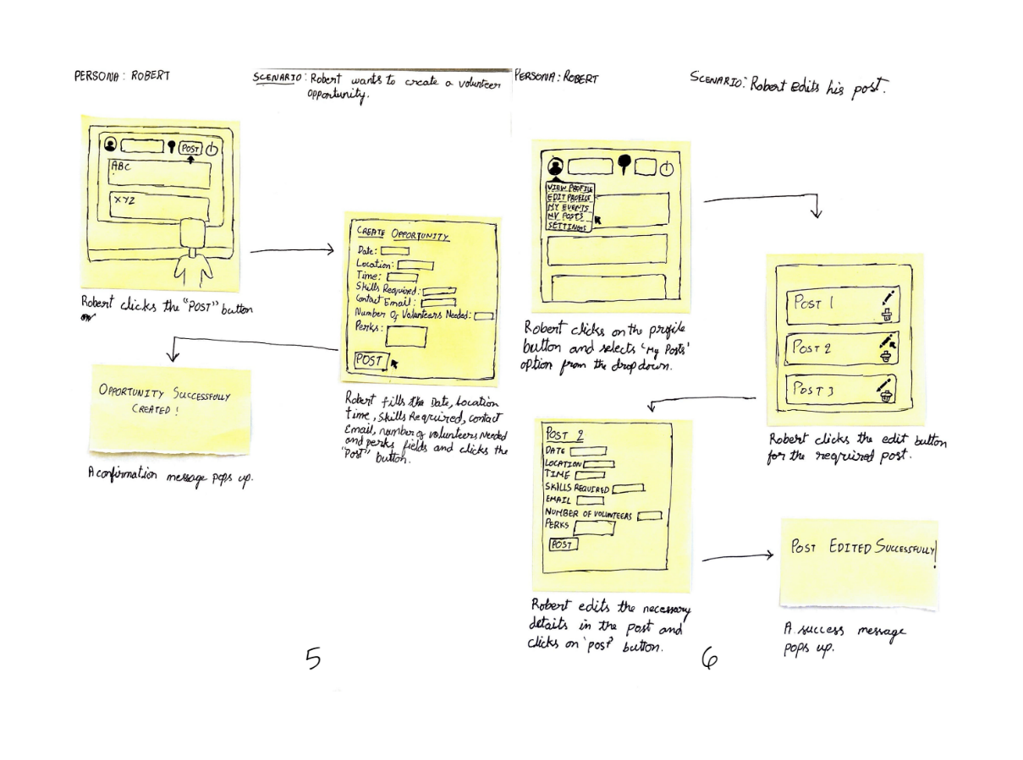

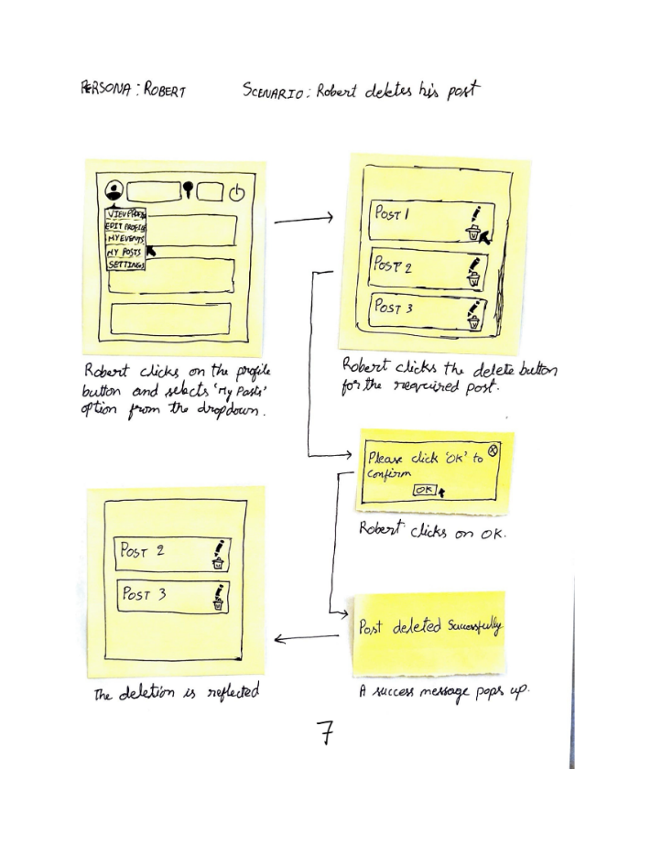

**Storyboard 2:**

**By Sricharan Mohan Kumar**

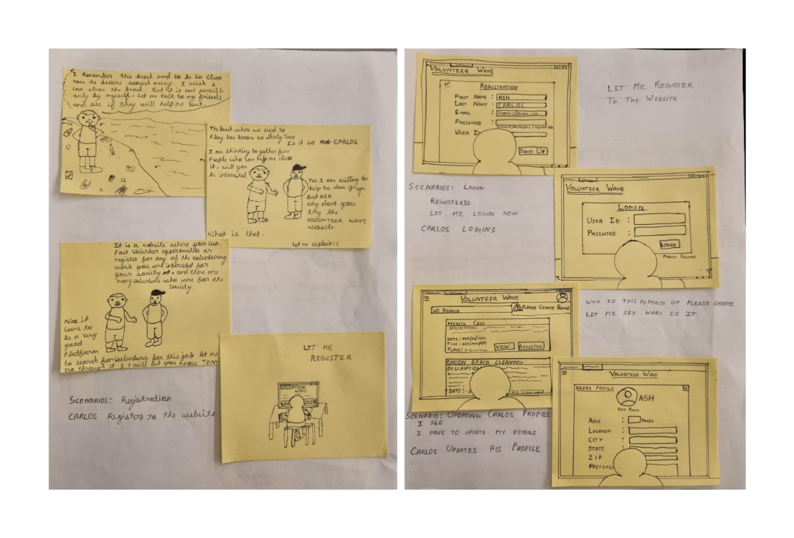

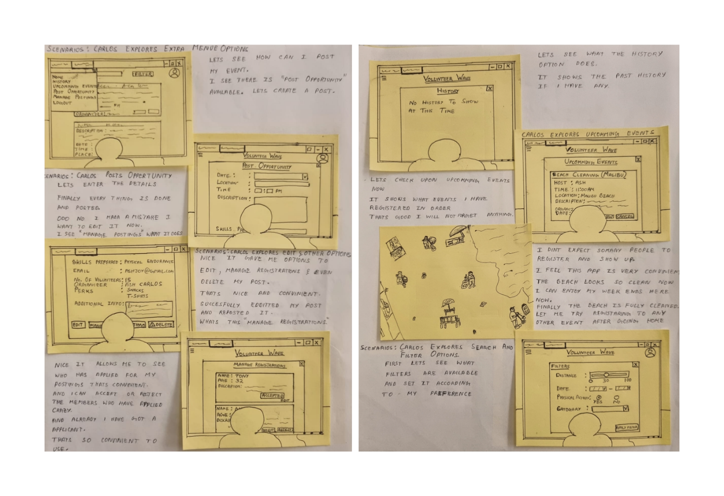

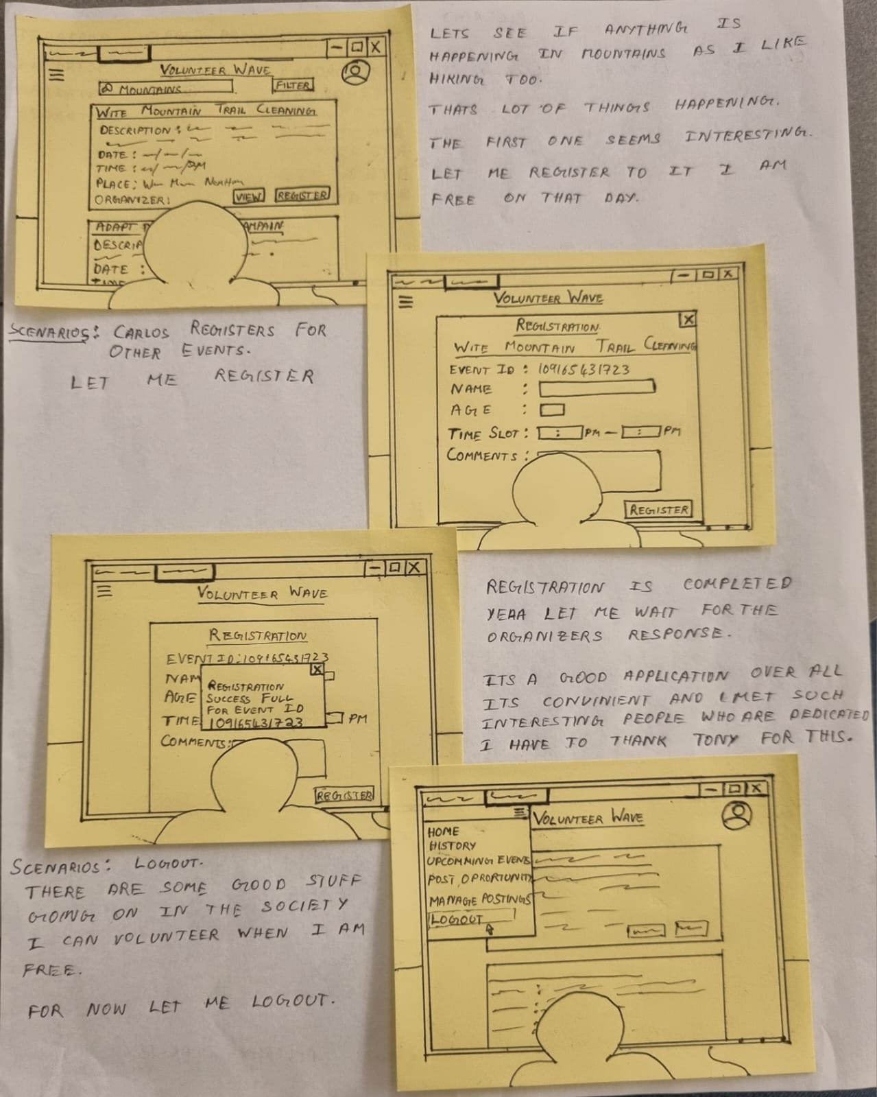

**Storyboard 3:**

**By Sukruth Kotturu**

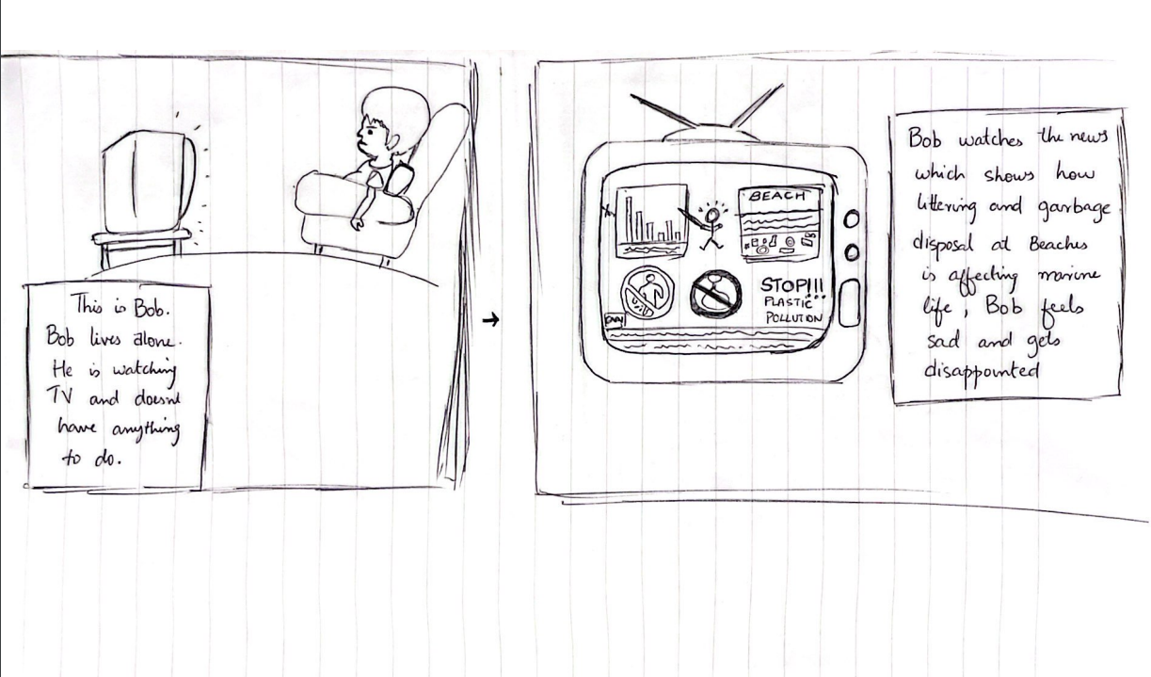

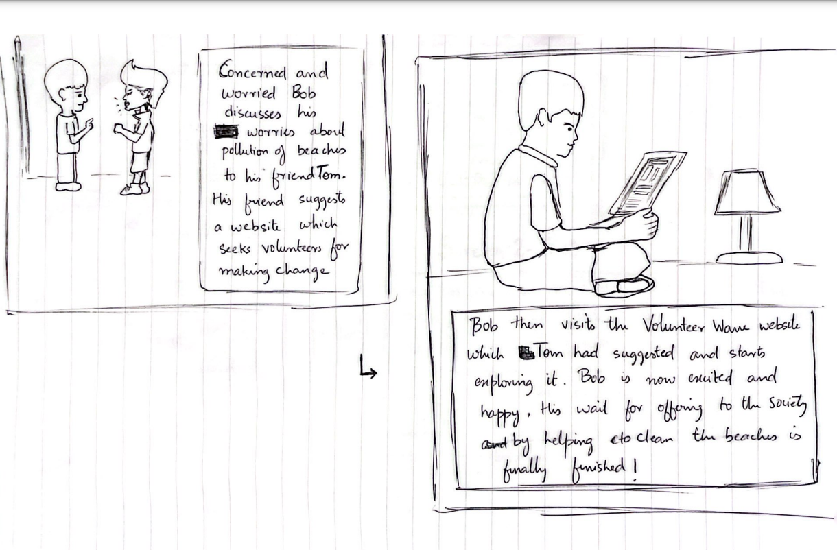

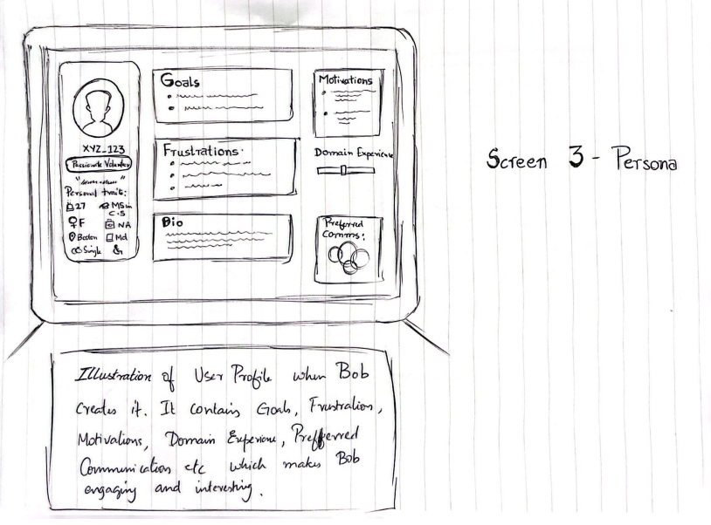

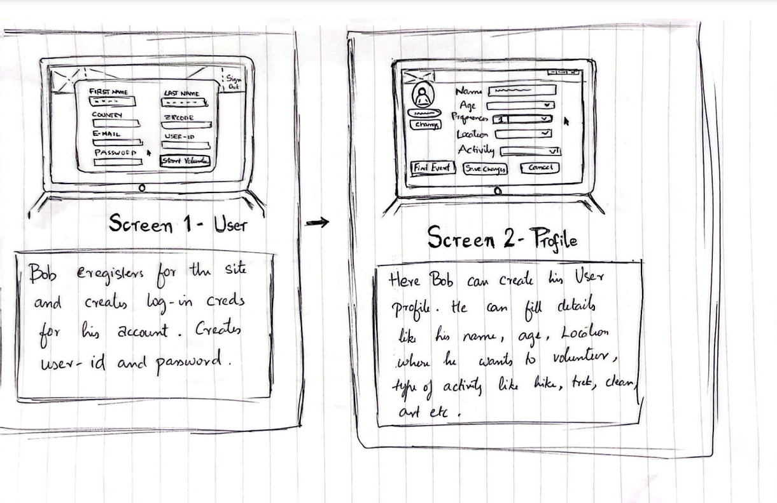

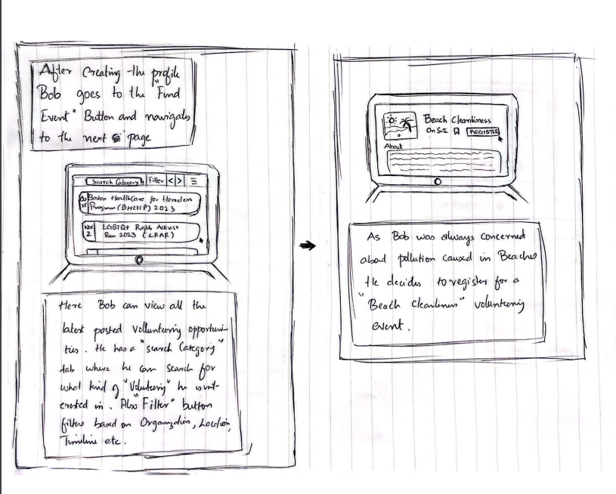

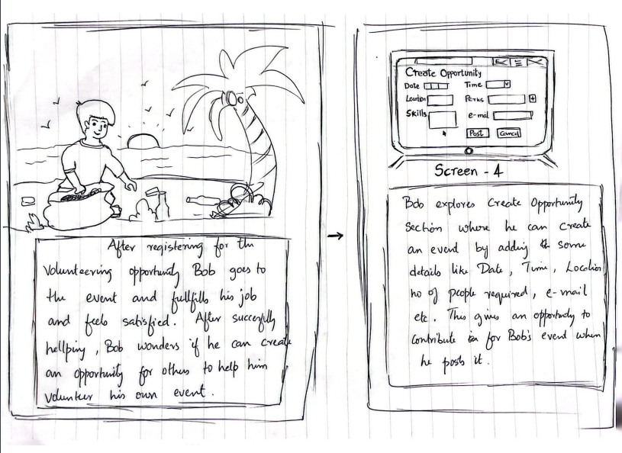

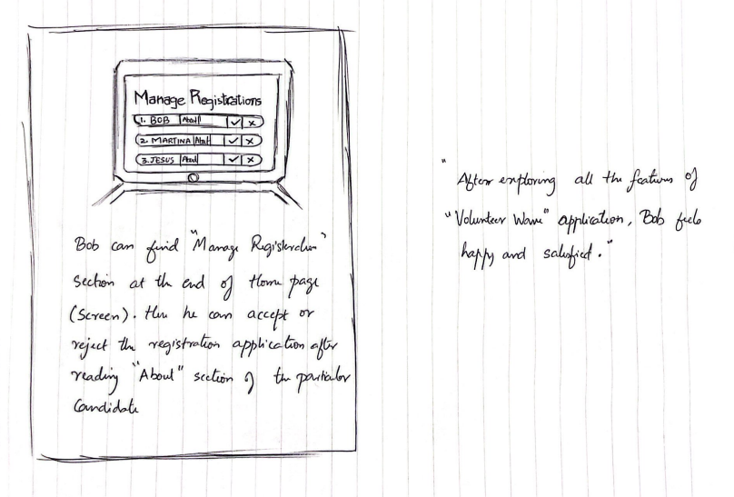

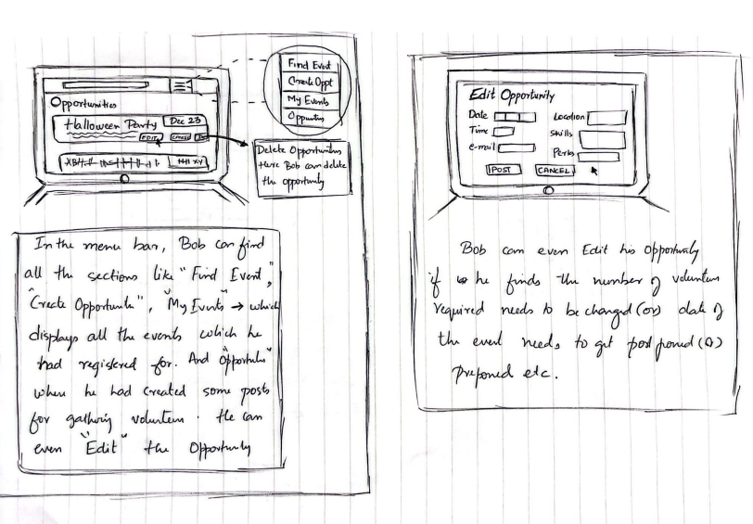

**Storyboard Evaluation and Selection**

After careful consideration, we have selected Sammed's storyboards as our preferred choice for several compelling reasons. Sammed's submissions include the crucial information, adhering to the HTA guidelines, and maintaining a concise narrative. They include important elements such as persona names and scenarios while staying focused on the core content and key features. In contrast, Sukruth's storyboard lacks essential elements, deviates from the HTA framework, and features an excessive length without subtask divisions. Sukruth's submission does not align with the expected standards of a proper storyboard.

Similarly, Charan's storyboard is commendably well-structured and effectively incorporates HTA's essential points in a clear manner. However, it falls short in terms of subtask divisions. Consequently, we will not choose Charan's storyboard either. In summary, Sammed's submissions align with our expectations for a proper storyboard, making them the top choice for our project.

**Selected Storyboard :**

**By Sammed Jain Dharmapal Prakash**







